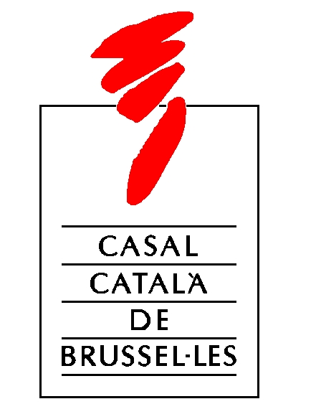

**5th BRUSSELS CATALAN CINEMA FESTIVAL**

At Espai Catalonia Europa, Rue by la Loi / Westraat 227 – 1040 BRU

**Free entrance with prior registration at:** [**activitats@casal-catala.be**](mailto:activitats@casal-catala.be)

**PROGRAMME 2014**

Monday, November 17th, at 7pm

THE TWIN SISTERS OF PONENT STREET (2010), by Marc Riba and Anna Solanas

Catalonia – Short film. Terror. – 13’. Over 16 years of age. Without dialogue.

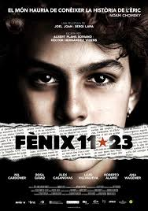

PHOENIX 11-23 (2011), by Joel Joan (Fènix 11-23)

Catalonia – Film fiction. Drama – 90’ - All publics – In Catalan with English subtitles.

In the autumn of 2004, Èric Bertran, a 14-year-old, creates a website inspired in Harry Potter and the Order of the Phoenix to defend the Catalan language. One evening, 30 militarised policemen from Madrid’s antiterrorism unit storm his house and accuse him of being a computer terrorist. His crime? Sending an email to a supermarket chain asking for labels in Catalan.

Tuesday, November 18th, at 7pm

THE OLIVE TREE (2013), by Frederic Menchón

Catalonia – Short film. Thriller. 16’. Over 12 years of age. In Spanish with English subtitles.

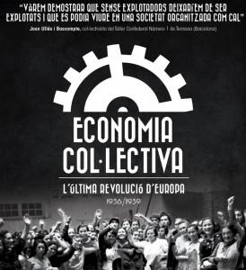COLLECTIVE ECONOMY (EUROPE’S LAST REVOLUTION) (2014), by Eulàlia Comas (Economia Col.lectiva. L’última revolució d’Europa)

Catalonia – Historic documentary. 66’. All publics. - In Catalan with English subtitles.

Documentary that exposes a little-known historic fact: During Spain’s Civil War (1936-1939), over 80% of Catalonia’s industry and services companyies were expropriated and managed by their own workers..

Thursday, November 20th, at 7pm

THE HEN (2014), by Manel Raga

Catalonia – Short film. Drama. – 11’. Over 16 years of age. Without dialogue.

[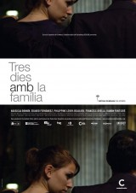](http://pics.filmaffinity.com/Tres_d_as_con_la_familia-485153163-large.jpg)TRES DIES AMB LA FAMILIA (2009), by Mar Coll

Catalonia – Fiction film. Drama. 86’ - All publics- In Catalan, Spanish and French with English subtitles.

Léa must travel to Girona suddenly, where her paternal grandfather just died. Her family, which she hasn’t seen since she moved abroad, is waiting for her.

Friday, November 21st, at 7pm

BIRTHDAY (2013), by Anna Petrus

Catalonia – Short film. Drama. – 11’. Over 7 years of age. In Catalan.

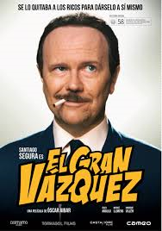EL GRAN VÁZQUEZ (2010), by Òscar Aibar

Catalonia – Fiction. Comedy, biography– 100’ – Over 18 years of age – In Spanish with English subtitles

Barcelona, the 60’s. Vázquez, the best cartoon artist in Spain, enjoy whatever he likes, when he likes. He does not pay anything, respects no rules and marries more than one woman at once. For Vázquez, life is a party.

ORGANISED BY:



WITH THE SUPPORT OF:



